DETAILED REPORT

ON

ELECTORAL

BONDS

*PRESENTED BY*

MANJUNADH RAMACHANDRULA

DATA ANALYST

**ELECTORAL BONDS**  V

PROJECTDESCRIPTION:  
The ELECTORAL BONDS Supreme Court of India h made a landmark decision by striking down the Electoral Bond scheme, emphasizing the importance of transparency in political funding. This decision aims to uphold voters' right to information and promote accountability in political financing. AS a response, the Election Commission of India has released comprehensive data, including donor and recipient information, through the State Bank of India. This dataset, available on the ECI's website, covers transactions FROM April 12, 2019, to January 11, 2024, and includes bond numbers to match purchasers with political parties. This move signifies a significant step towards greater transparency and aligns with democratic principles.

**DATA SOURCES:**

These are the official Sites WHERE the data is released by the government.

* <https://www.eci.gov.in/disclosure-of-electoral-bonds>
* [https://enforcementdirectorate.gov.in/press-releASe](https://enforcementdirectorate.gov.in/press-release) (Data available only since 2021)
* <https://cag.gov.in/en/audit-report> (Data extracted FROM 2018)
* [https://incometaxindia.gov.in/Pages/press-releASes.ASpx](https://incometaxindia.gov.in/Pages/press-releases.aspx) (Data extracted FROM 2010)
* [https://cbi.gov.in/press-releASes](https://cbi.gov.in/press-releases) (Data extracted FROM 2018)
* [https://www.mca.gov.in/content/mca/global/en/mca/mASter-data/MDS.html](https://www.mca.gov.in/content/mca/global/en/mca/master-data/MDS.html)
* [pib.gov](https://pib.gov.in/Pressreleaseshare.aspx?PRID=1566604)

All the bank branches do not have the authority to issue electoral bonds only few branches of SBI bank can issue them and this table contains the details of that banks and based on the branch code we can connect to the receiver and donor data.

**KAGGLE SOURCES**:

[https://www.kaggle.com/datASets/uplytics/electoral-bonds-india-complete-2024-datASet/data](https://www.kaggle.com/datasets/uplytics/electoral-bonds-india-complete-2024-dataset/data)

FROM this SQL Project we are going to solve interesting queries. Data is AS follows:

1. Donor Data (Details of the purchaser with the primary and foreign keys)
2. Receiver Data (Details of encashed party with necessary information)
3. Bond Data (Details of Bond details of essential information)
4. Bank Data (Details of Bank WHERE the purchasing and encashment takes place)

DONOR DATA:

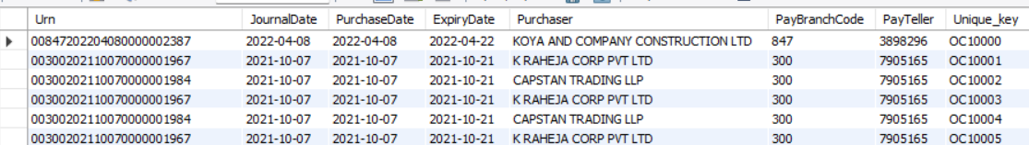

RECEIVER DATA:

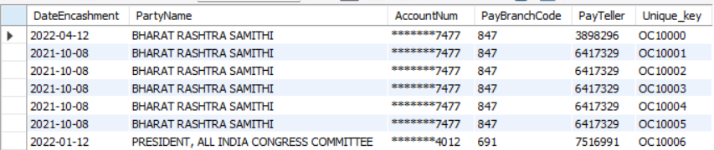

BOND DATA: BANK DATA:

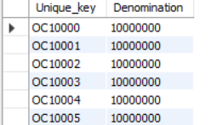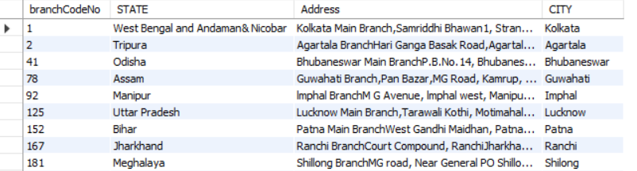

LET’S SOLVE FEW INTERESTING QUERIES IN MySQL …...!

1.To find out how much donors spent on bonds:

SELECT SUM (DENOMINATION) AS money

FROM DONORDATA AS D

LEFT JOIN BONDDATA AS B

USING (UNIQUE_KEY);

121555132000 MONEY SPEND BY THE DONOR

OUTPUT:

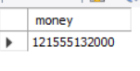

2.To find out total fund politicians got

SELECT SUM (DENOMINATION) AS TOTAL_FUND_POLITICANS_GOT

FROM BONDDATA AS B

JOIN RECEIVERDATA AS R

ON B. UNIQUE_KEY=R.UNIQUE_KEY

TOTAL FUND POLITICIANS GOT OF RS 127690893000.

OUTPUT:

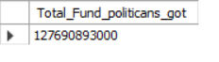

3. Find out the total amount of unaccounted money received by parties

SELECT SUM (DENOMINATION) AS UNACCOUNTED_MONEY

FROM BONDDATA

WHERE UNIQUE_KEY IN (

SELECT R. UNIQUE_KEY

FROM DONORDATA AS D

RIGHT JOIN RECEIVERDATA AS R

ON D. UNIQUE_KEY=R.UNIQUE_KEY

WHERE D. UNIQUE_KEY IS NULL

);

6232110000 MONEY IS SPEND AS UNACCOUNTED.

OUTPUT:

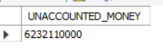

4. Find year wise how much money is spent on bonds

SELECT YEAR(DATEENCASHMENT) AS "YEAR", SUM(DENOMINATION) AS "TOTAL_DENOMINATION"

FROM BONDDATA AS B

RIGHT JOIN RECEIVERDATA AS R

ON B. UNIQUE_KEY=R.UNIQUE_KEY

GROUP BY YEAR(DATEENCASHMENT)

ORDER BY YEAR(DATEENCASHMENT);

OUTPUT:

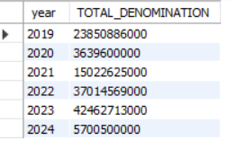

5. In which month most amount is spent on bonds

WITH TOTAL AS (

SELECT DISTINCT (MONTHNAME (PURCHASEDATE)) AS "MONTH",

SUM(DENOMINATION) AS TOTAL_DENOMINATIONS

FROM DONORDATA AS D

LEFT JOIN BONDDATA AS B

ON D. UNIQUE_KEY= B. UNIQUE_KEY

GROUP BY MONTH)

SELECT * FROM TOTAL

WHERE TOTAL_DENOMINATIONS = (SELECT MAX(TOTAL_DENOMINATIONS)

FROM TOTAL);

APRIL MONTH HAVE HIGHEST PURCHASE OF BONDS.

OUTPUT:



6. Find out which company bought the highest number of bonds.

SELECT *

FROM DONORDATA;

WITH K AS (

SELECT DISTINCT(PURCHASER), COUNT(PURCHASER)AS "NO_OF_BONDS"

FROM DONORDATA AS D

LEFT JOIN BONDDATA AS B

ON D. UNIQUE_KEY=B.UNIQUE_KEY

GROUP BY PURCHASER)

SELECT * FROM K

WHERE NO_OF_BONDS = (SELECT MAX(NO_OF_BONDS)

FROM K);

FUTURE GAMING AND HOTEL SERVICES PRIVATE LIMITED BOUGHT HIGHEST NUMBER OF BONDS WITH 1368

OUTPUT:



7. Find out which company spent the most on electoral bonds.

WITH MONEY AS (

SELECT DISTINCT(PURCHASER), SUM(DENOMINATION) AS "MONEY_SPEND" FROM DONORDATA AS D

LEFT JOIN BONDDATA AS B

USING(UNIQUE_KEY)

GROUP BY PURCHASER)

SELECT * FROM MONEY

WHERE MONEY_SPEND= (SELECT MAX(MONEY_SPEND)

FROM MONEY);

FUTURE GAMING AND HOTEL SERVICES PRIVATE LIMITED BOUGHT HIGHEST MONEY SPEND WITH 13680000000

OUTPUT:

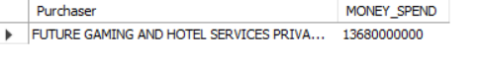

8. List companies which paid the LEAST to political parties.

WITH MONEY AS (

SELECT DISTINCT(PURCHASER), SUM(DENOMINATION) AS "MONEY_SPEND”, UNIQUE_KEY FROM DONORDATA AS D

LEFT JOIN BONDDATA AS B

USING(UNIQUE_KEY)

GROUP BY PURCHASER, UNIQUE_KEY),

MONEY1 AS (SELECT DISTINCT(PARTYNAME), UNIQUE_KEY

FROM RECEIVERDATA AS R),

MONEY0 AS (

SELECT * FROM MONEY AS M

JOIN MONEY1 AS M1

USING(UNIQUE_KEY)),

MONEY2 AS (

SELECT PURCHASER, SUM(MONEY_SPEND) AS CASH

` FROM MONEY0

WHERE PARTYNAME IN (SELECT DISTINCT(PARTYNAME)

FROM MONEY0)

GROUP BY PURCHASER),

MONEY3 AS (

SELECT PURCHASER, CASH FROM MONEY2

WHERE CASH= (SELECT MIN(CASH) FROM MONEY2)

GROUP BY PURCHASER)

SELECT * FROM MONEY3

ARAVIND S IS THE ONLY PURCHASER WHO PAID LEASTTO THE POLITICAL PARTIES

OUTPUT:



9. Which political party received the highest CASH?

#USING CTE's

WITH MAXDATA AS (

SELECT PARTYNAME, SUM(DENOMINATION) AS TOTAL_DENOMINATIONS

FROM RECEIVERDATA AS R

LEFT JOIN BONDDATA AS B

USING(UNIQUE_KEY)

GROUP BY PARTYNAME)

SELECT * FROM MAXDATA

WHERE TOTAL_DENOMINATIONS= (SELECT MAX(TOTAL_DENOMINATIONS) FROM MAXDATA);

BHARATHEY JANATHA PARTY RECIEVED HIGHEST CASH AMONG ALL THE PARTIES WITH RS 60605111000

OUTPUT:



10. Which political party received the highest number of electoral bonds?

# USING CTE'S

WITH NO_OF_BONDS AS (

SELECT PARTYNAME, COUNT (*) AS TOTAL_BONDS

FROM RECEIVERDATA AS R

LEFT JOIN BONDDATA AS B

USING (UNIQUE_KEY)

GROUP BY PARTYNAME)

SELECT * FROM NO_OF_BONDS

WHERE TOTAL_BONDS= (SELECT MAX(TOTAL_BONDS) FROM NO_OF_BONDS);

BHARATIYA JANATA PARTY RECIEVED 8633 OF BONDS.

OUTPUT:

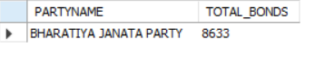

11. Which political party received the LEAST CASH?

WITH CASH AS (

SELECT PARTYNAME, SUM(DENOMINATION) AS CASH_OBTAINED

FROM RECEIVERDATA AS R

LEFT JOIN BONDDATA AS B

ON R. UNIQUE_KEY =B. UNIQUE_KEY

GROUP BY PARTYNAME)

SELECT * FROM CASH

WHERE CASH_OBTAINED= (SELECT MIN(CASH_OBTAINED) FROM CASH);

GOA FORWARD PARTY RECIEVES THE LEAST CASH WITH 3500000.

OUTPUT:



12. Which political party received the LEAST number of electoral bonds?

WITH BONDS AS (

SELECT PARTYNAME, COUNT(PARTYNAME) AS NO_OF_BONDS FROM RECEIVERDATA AS R

GROUP BY PARTYNAME)

SELECT * FROM BONDS

WHERE NO_OF_BONDS= (SELECT MIN(NO_OF_BONDS) FROM BONDS);

JAMMU AND KASHMIR NATIONAL CONFERENCE PARTY RECEIVES THE LEASTNO OF BONDS WITH 5 IN NUMBER

OUTPUT:



13. Find the 2nd highest donor in terms of amount he paid?

WITH SECOND_DONOR AS (

SELECT PURCHASER, SUM(DENOMINATION) AS CASH,

DENSE_RANK () OVER (ORDER BY SUM(DENOMINATION) DESC) AS RANKS FROM DONORDATA AS D

LEFT JOIN BONDDATA AS B

ON D. UNIQUE_KEY= B. UNIQUE_KEY

GROUP BY PURCHASER

ORDER BY CASH DESC)

SELECT PURCHASER, CASH FROM SECOND_DONOR

WHERE RANKS=2;

Megha Engineering and Infrastructures private limited back the 2nd donor for

electoral bonds.

OUTPUT:

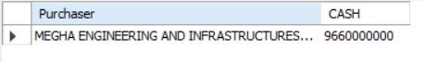

14. Find the party which received the second highest donations?

WITH HIGHEST_BONDS AS (

SELECT PARTYNAME, SUM(DENOMINATION) AS CASH,

DENSE_RANK () OVER (ORDER BY SUM(DENOMINATION) DESC) AS RANKS FROM RECEIVERDATA AS R

LEFT JOIN BONDDATA AS B

ON R. UNIQUE_KEY= B. UNIQUE_KEY

GROUP BY PARTYNAME)

SELECT PARTYNAME, CASH FROM HIGHEST_BONDS

WHERE RANKS=2;

ALL INDIA TRINAMOOL CONGRESS RECIEVED 2ND `HIGHEST DENOMINATIONS WITH RS 16095314000

OUTPUT:

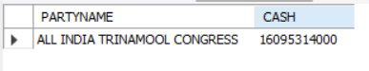

15. Find the party which received the second highest number of bonds?

WITH BONDS AS (

SELECT PARTYNAME, COUNT(PARTYNAME) AS NO_OF_BONDS,

DENSE_RANK () OVER (ORDER BY COUNT(PARTYNAME) DESC) AS RANKS FROM RECEIVERDATA AS R

GROUP BY PARTYNAME)

SELECT PARTYNAME, NO_OF_BONDS FROM BONDS

WHERE RANKS=2;

ALL INDIA TRINAMOOL CONGRESS RECIEVES THE 2ND LARGEST PARTY TO RECIEVE HIGHEST NO OF BONDS WITH 3305.

OUTPUT:



16. In which city were the greatest number of bonds purchased?

WITH PURCHASE AS (

SELECT DISTINCT(CITY), COUNT(PURCHASER) AS NO_OF_BONDS FROM DONORDATA AS D

RIGHT JOIN BANKDATA AS B

ON D. PAYBRANCHCODE= B. BRANCHCODENO

GROUP BY CITY

ORDER BY NO_OF_BONDS DESC)

SELECT * FROM PURCHASE

WHERE NO_OF_BONDS= (SELECT MAX(NO_OF_BONDS) FROM PURCHASE);

KOLKATA RECIEVED MORE NO OF BONDS WITH 5420

OUTPUT:



17. In which city was the highest amount spent on electoral bonds?

WITH SPEND AS (

SELECT PAYBRANCHCODE, DENOMINATION FROM DONORDATA AS D

JOIN BONDDATA AS B

ON D. UNIQUE_KEY=B.UNIQUE_KEY),

BOND1 AS (SELECT * FROM SPEND),

BOND2 AS (

SELECT CITY, SUM(DENOMINATION) AS SPEND_CASH

FROM BOND1

JOIN BANKDATA AS BAN

ON BOND1.PAYBRANCHCODE=BAN.BRANCHCODENO

GROUP BY CITY)

SELECT CITY, SPEND_CASH FROM BOND2

WHERE SPEND_CASH= (SELECT MAX(SPEND_CASH) FROM BOND2);

HYDERABAD RECIEVED HIGHEST SPEND CASH WITH 29189070000

OUTPUT:



18. In which city were the LEAST number of bonds purchased?

WITH BONDS AS (

SELECT DISTINCT(CITY)AS "CITY", COUNT(UNIQUE_KEY) AS "NO_OF_BONDS"FROM BANKDATA AS B

RIGHT JOIN DONORDATA AS D

ON B. BRANCHCODENO =D. PAYBRANCHCODE

GROUP BY B. CITY)

SELECT * FROM BONDS

WHERE NO_OF_BONDS= (SELECT MIN(NO_OF_BONDS) FROM BONDS);

RANCHI CITY PURCHASED LEAST NO OF BONDS WITH 5

OUTPUT:



19. In which city were the greatest number of bonds enchased?

SELECT * FROM RECEIVERDATA;

WITH RECIEVED AS (

SELECT DISTINCT (CITY) AS "CITY", COUNT(UNIQUE_KEY) AS "NO_OF_BONDS" FROM RECEIVERDATA AS R

LEFT JOIN BANKDATA AS B

ON R. PAYBRANCHCODE= B. BRANCHCODENO

GROUP BY CITY)

SELECT * FROM RECIEVED

WHERE NO_OF_BONDS= (SELECT MAX(NO_OF_BONDS) FROM RECIEVED);

NEW DELHI IS THE CITY WHICH Has HIGHEST NO OF RATE OF ENCASH MENT.

OUTPUT:



20.In which city were the LEAST number of bonds enchased?

WITH RECIEVED AS (

SELECT DISTINCT(CITY) AS "CITY", COUNT(UNIQUE_KEY) AS "NO_OF_BONDS_ENCHASED" FROM RECEIVERDATA AS R

LEFT JOIN BANKDATA AS B

ON R. PAYBRANCHCODE=B.BRANCHCODENO

GROUP BY CITY)

SELECT * FROM RECIEVED

WHERE NO_OF_BONDS_ENCHASED= (SELECT MIN(NO_OF_BONDS_ENCHASED) FROM RECIEVED);

SRINAGAR HAS THE LEASTNO OF BONDS ENCHASED WITH 5

OUTPUT:

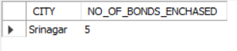

21. List the branches WHERE no electoral bonds were bought; if none, mention it AS null.

TOFIND THE LIST OF BRANCHES WHERE NO ELECTRO BONDS ARE ENCHASED

WITH ENCASH AS (

SELECT CITY, BRANCHCODENO FROM BANKDATA AS B

LEFT JOIN RECEIVERDATA AS R

ON B. BRANCHCODENO= R. PAYBRANCHCODE

WHERE R. PARTYNAME IS NULL)

SELECT * FROM ENCASH;

THERE ARE 16 BRANCHES WHERE NO ELECTROL BONDS ARE ENCASHED.

OUTPUT:

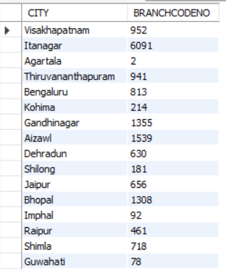

# TO FIND THE LIST OF BRANCHES WHERE NO ELECTRO BONDS ARE PURCHASED.

WITH PURCHASE AS (

SELECT BRANCHCODENO, CITY FROM BANKDATA AS BAN

LEFT JOIN DONORDATA AS D

ON BAN.BRANCHCODENO=D. PAYBRANCHCODE

WHERE D. PURCHASER IS NULL)

SELECT COUNT (*) FROM PURCHASE;

THERE ARE 10 BRANCHES WHERE NO ELECTROL BONDS ARE PURCHASED.

OUTPUT:

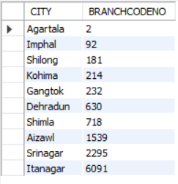

22. Break down how much money is spent on electoral bonds for each year.

#MONEY SPEND ON ELECTROL BONDS IN EVERY YEAR BY THE DONORS.

SELECT YEAR(PURCHASEDATE), SUM(DENOMINATION) AS "MONEY_SPEND" FROM DONORDATA AS D

LEFT JOIN BONDDATA AS B

USING(UNIQUE_KEY)

GROUP BY YEAR(PURCHASEDATE)

ORDER BY YEAR(PURCHASEDATE);

SELECT * FROM RECEIVERDATA;

OUTPUT:

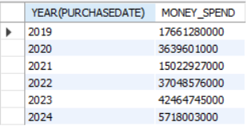

#MONEY SPEND ON ELECTROL BONDS IN EVERY YEAR BY THE RECIEVERS.

SELECT YEAR(DATEENCASHMENT), SUM(DENOMINATION) AS "SPEND_MONEY" FROM RECEIVERDATA AS R

LEFT JOIN BONDDATA AS B

USING (UNIQUE_KEY)

GROUP BY YEAR(DATEENCASHMENT)

ORDER BY YEAR(DATEENCASHMENT);

OUTPUT:



23. Break down how much money is spent on electoral bonds for each year and provide the year and the amount. Provide values

#FOR THE HIGHEST AND LEASTYEAR AND AMOUNT.

WITH HIGH AS (

SELECT YEAR(PURCHASEDATE), SUM(DENOMINATION) AS "HIGHEST_MONEY_SPEND" FROM DONORDATA AS D

LEFT JOIN BONDDATA AS B

USING(UNIQUE_KEY)

GROUP BY YEAR(PURCHASEDATE))

SELECT * FROM HIGH

WHERE HIGHEST_MONEY_SPEND= (SELECT MAX(HIGHEST_MONEY_SPEND)

FROM HIGH);

HIGHEST MONEY SPEND IN THE YEAR 2023 WITH RS 42464745000 BY THE DONOR

OUTPUT:



WITH LOW AS (

SELECT YEAR(PURCHASEDATE), SUM(DENOMINATION) AS "LEAST_MONEY_SPEND" FROM DONORDATA AS D

LEFT JOIN BONDDATA AS B

USING(UNIQUE_KEY)

GROUP BY YEAR(PURCHASEDATE))

SELECT * FROM LOW

WHERE LEAST_MONEY_SPEND= (SELECT MIN(LEAST_MONEY_SPEND) FROM LOW);

LEASTMONEY SPEND IN THE YEAR 2020 WITH RS 3639601000 BY THE DONOR

OUTPUT:



24. Find out how many donors bought the bonds but did not donate to any political party?

SELECT COUNT (D. UNIQUE_KEY) AS "DONOR" FROM DONORDATA AS D

LEFT JOIN RECEIVERDATA AS R

ON D. UNIQUE_KEY=R.UNIQUE_KEY

WHERE R. UNIQUE_KEY IS NULL;

THERE ARE 130 DONOR BOUGHT THE BONDS BUT THEY DIDNOT DONATE TO ANY POLITICAL PARTY.

OUTPUT:



25. Find out the money that could have gone to the PM Office, Assuming the above question Assumption (Domain Knowledge)

WITH PN AS (

SELECT D. UNIQUE_KEY FROM DONORDATA AS D

LEFT JOIN RECEIVERDATA AS R

USING(UNIQUE_KEY)

WHERE R. UNIQUE_KEY IS NULL)

SELECT SUM(DENOMINATION) AS PM_RELIEF_FUND FROM BONDDATA

JOIN PN

USING(UNIQUE_KEY);

96349000 RS WERE SEND TO PM RELIEF FUND SINCE NO PARTY ENCASHED THE BOND.

OUTPUT:



26. Find out how many bonds don't have donors Associated with them.

SELECT COUNT(PARTYNAME) AS "DONOR_LESS_BONDS" FROM RECEIVERDATA AS R

LEFT JOIN DONORDATA AS D

ON R. UNIQUE_KEY=D.UNIQUE_KEY

WHERE PURCHASER IS NULL;

# THERE ARE 1680 BONDS WHICH DONOT HAVE DONORS.

OUTPUT:



27. Pay Teller is the employee ID who either created the bond or redeemed it. So, find the employee ID who issued the highest

number of bonds.

# PAYTELLER ISSUED BONDS IN THE DONATION SIDE

WITH DONOR AS (

SELECT PAYTELLER, COUNT (*) AS "NO_OF_BONDS" FROM DONORDATA

GROUP BY PAYTELLER

ORDER BY NO_OF_BONDS DESC)

SELECT * FROM DONOR

WHERE NO_OF_BONDS= (SELECT MAX(NO_OF_BONDS) FROM DONOR);

6405134 IS THE ONLY PAYTELLER WHO IS RESPONSIBLE FOR THE 1946 BONDS.

OUTPUT:



#PAYTELLER ISSUED BONDS IN THE RECIEVER SIDE

WITH RECIEVE AS (

SELECT PAYTELLER, COUNT (*) AS "NO_OF_BONDS" FROM RECEIVERDATA

GROUP BY PAYTELLER

ORDER BY NO_OF_BONDS DESC)

SELECT * FROM RECIEVE

WHERE NO_OF_BONDS= (SELECT MAX(NO_OF_BONDS) FROM RECIEVE);

3645 BONDS ARE ISSUED BY THE 7516991 PAYTELLER

OUTPUT:



28. Find the employee ID who issued the LEAST number of bonds.

WITH DONATE AS (

SELECT PAYTELLER, COUNT (*) AS "LEAST_NO_OF_BONDS" FROM DONORDATA AS D

GROUP BY PAYTELLER

ORDER BY PAYTELLER)

SELECT * FROM DONATE

WHERE LEAST_NO_OF_BONDS= (SELECT MIN(LEAST_NO_OF_BONDS)

FROM DONATE);

5575761 AND 5578876 ARE THE TWO PAYTELLER NUMBERS MAKE LEASTNO OF BONDS FROM THE DONOR SIDE WITH 1 BOND.

OUTPUT:

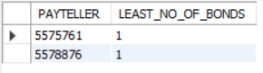

# RECIEVER END

WITH ACQUIRE AS (

SELECT PAYTELLER, COUNT (*) AS "LEAST_NO_OF_BONDS" FROM RECEIVERDATA AS R

GROUP BY PAYTELLER

ORDER BY PAYTELLER)

SELECT * FROM ACQUIRE

WHERE LEAST_NO_OF_BONDS= (SELECT MIN(LEAST_NO_OF_BONDS)

FROM ACQUIRE);

5880793, 6596169, 7626436 ARE THE THREELEASTINVOLVING EMPLOYEES IN THE ENCASHMENT OF MONEY IN THE RECIEVER SIDE WITH 3 BONDS.

OUTPUT:

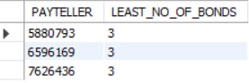

29. Find the employee ID who Assisted in redeeming or enchasing bonds the most.

WITH RECIEVE AS (

SELECT PAYTELLER, COUNT (*) AS "MOST_BONDS" FROM RECEIVERDATA AS R

GROUP BY PAYTELLER

ORDER BY COUNT(PAYTELLER))

SELECT * FROM RECIEVE

WHERE MOST_BONDS = (SELECT MAX(MOST_BONDS) FROM RECIEVE);

PAYTELLER WITH 7516991 ENCASH 3645 BONDS FROM THE RECIEVER END.

OUTPUT:

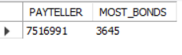

30. Find the employee ID who Assisted in redeeming or enchasing bonds the LEAST

WITH EMP AS (

SELECT PAYTELLER, COUNT(PAYTELLER) AS "NO_OF_BONDS"

FROM RECEIVERDATA AS R

GROUP BY PAYTELLER)

SELECT * FROM EMP

WHERE NO_OF_BONDS = (SELECT MIN(NO_OF_BONDS) FROM EMP);

OUTPUT:

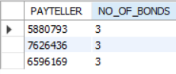

LET US SEE FEW MORE INTERESTING QUERIES

1. Tell me total how many bonds are created?

#TOTAL NO OF KEYS CREATED = DONOR SIDE KEYS + UNACCOUNTED KEYS

WITH DONOR AS (

SELECT UNIQUE_KEY AS DONOR_KEYS FROM DONORDATA),

UNACCOUNTED AS (SELECT * FROM DONOR AS D

RIGHT JOIN RECEIVERDATA AS R

ON D. DONOR_KEYS=R.UNIQUE_KEY),

UNACCOUNTED1 AS (

SELECT UNIQUE_KEY AS "UNACCOUNTED" FROM UNACCOUNTED

WHERE DONOR_KEYS IS NULL),

TOTAL AS (

SELECT * FROM UNACCOUNTED1

UNION ALL

SELECT * FROM DONOR)

SELECT COUNT (*) AS "TOTAL KEYS GENERATED” FROM TOTAL;

THERE ARE 20551 UNIQUE KEYS GENERATED

OUTPUT:

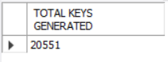

2. Find the count of Unique Denominations provided by SBI?

SELECT COUNT (DISTINCT (DENOMINATION)) AS NO_OF_DENOMINATIONS FROM BONDDATA;

THERE ARE 5 DISTINCT DENOMINATIONS PROVIDED BY SBI

OUTPUT:



3. List all the unique denominations that are available?

SELECT DISTINCT(DENOMINATION) FROM BONDDATA

ORDER BY DENOMINATION;

THESE ARE THE LIST OF DINOMINATIONS FROM SBI

OUTPUT:

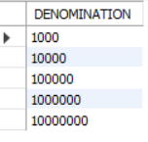

4. Total money received by the bank for selling bonds

SELECT SUM(DENOMINATION) AS "TOTAL_DENOMINATION_FROM_BANK" FROM DONORDATA AS R

LEFT JOIN BONDDATA AS B

USING(UNIQUE_KEY);

121555132000 RS RECIEVED AFTER SELLING BONDS

OUTPUT:

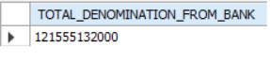

5. Find the count of bonds for each denomination that are created.

SELECT DISTINCT(DENOMINATION) AS DENOMINATION, COUNT(UNIQUE_KEY) AS "NO_OF_BONDS" FROM BONDDATA AS B

RIGHT JOIN DONORDATA AS D

USING(UNIQUE_KEY)

GROUP BY DENOMINATION

ORDER BY DENOMINATION;

THESE ARE THE COUNT OF BONDS WITH RESPECT OT THEIR DENOMINATIONS

1000 132

10000 220

100000 2228

1000000 4620

10000000 11671

OUTPUT:

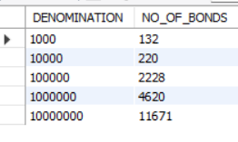

6. Find the count and Amount or Valuation of electoral bonds for each denomination.

SELECT DISTINCT(DENOMINATION) AS DENOMINATION, COUNT(UNIQUE_KEY) AS "NO_OF_BONDS”, SUM(DENOMINATION) AS AMOUNT FROM BONDDATA AS B

RIGHT JOIN DONORDATA AS D

USING(UNIQUE_KEY)

GROUP BY DENOMINATION

ORDER BY DENOMINATION;

THESE ARE THE TOTAL AMOUNT WITH THE NO OF BONDS TO THE RESPECTIVE DENOMINATIONS.

1000 132 132000

10000 220 2200000

100000 2228 222800000

1000000 4620 4620000000

10000000 11671 116710000000

OUTPUT:

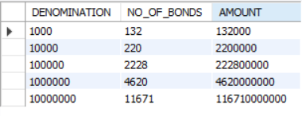

7. Number of unique bank branches WHERE we can buy electoral bond?

SELECT DISTINCT (COUNT(BRANCHCODENO)) AS BRANCHES FROM BANKDATA;

THERE ARE 29 BRANCHES FROM WHICH WE CAN ABLE TO BUY THE ELECTROL BONDS.

OUTPUT:



8. How many companies bought electoral bonds

SELECT COUNT(DISTINCT(PURCHASER)) AS NO_OF_COMPANIES FROM DONORDATA;

THERE ARE 1228 DISTINCT COMPANIES BOUGHT ELECTORAL BONDS.

OUTPUT:



9. How many companies made political donations

WITH COMPANIES AS (

SELECT PURCHASER, D. UNIQUE_KEY AS "DONOR_KEY”, R. UNIQUE_KEY AS "RECEIVER_KEY" FROM DONORDATA AS D

JOIN RECEIVERDATA AS R

USING (UNIQUE_KEY))

SELECT COUNT(DISTINCT(PURCHASER)) FROM COMPANIES;

1205 COMPANIES MADE POLITICAL DONATIONS.

OUTPUT:



10. How many numbers of parties received donations

SELECT COUNT(DISTINCT(PARTYNAME)) AS NO_OF_PARTIES

FROM DONORDATA AS D

JOIN RECEIVERDATA AS R

USING (UNIQUE_KEY);

THERE ARE 23 PARTIES RECIEVED DONATIONS.

OUTPUT:



11. List all the political parties that received donations

SELECT DISTINCT(PARTYNAME) FROM RECEIVERDATA;

BHARAT RASHTRA SAMITHI

PRESIDENT, ALL INDIA CONGRESS COMMITTEE

ALL INDIA TRINAMOOL CONGRESS

BHARATIYA JANATA PARTY

SHIVSENA

BIJU JANATA DAL

TELUGU DESAM PARTY

AAM AADMI PARTY

DRAVIDA MUNNETRA KAZHAGAM (DMK)

SIKKIM KRANTIKARI MORCHA

YSR CONGRESS PARTY (YUVAJANA SRAMIKA RYTHU CONGRESS PARTY)

NATIONALIST CONGRESS PARTY MAHARASHTRA PRADESH

JHARKHAND MUKTI MORCHA

JANASENA PARTY

RASHTRIYA JANTA DAL

JANATA DAL (SECULAR)

SIKKIM DEMOCRATIC FRONT

ADYAKSHA SAMAJVADI PARTY

BIHAR PRADESH JANTA DAL(UNITED)

ALL INDIA ANNA DRAVIDA MUNNETRA KAZHAGAM

SHIROMANI AKALI DAL

GOA FORWARD PARTY

MAHARASHTRAWADI GOMNTAK PARTY

JAMMU AND KASHMIR NATIONAL CONFERENCE

OUTPUT:

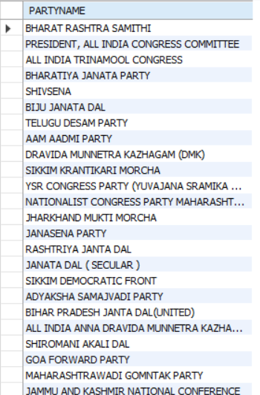

12. What is the average amount that each political party received

WITH RECIEVED AS (

SELECT PARTYNAME, SUM(DENOMINATION) AS MONEY FROM RECEIVERDATA AS R

LEFT JOIN BONDDATA AS B

USING(UNIQUE_KEY)

GROUP BY PARTYNAME)

SELECT AVG(MONEY) AS AVERAGE_MONEY_RECEIVED FROM RECIEVED;

AVERAGE AMOUNT RECEIVED BY EACH POLITOCAL PARTY IS RS 5320453875

OUTPUT:



13. What is the average bond value produced by bank

WITH VALUE_BOND AS (

SELECT DISTINCT(PURCHASER), SUM(DENOMINATION) AS MONEY FROM DONORDATA

LEFT JOIN BONDDATA

USING (UNIQUE_KEY)

GROUP BY PURCHASER)

SELECT AVG(MONEY) FROM VALUE_BOND;

AVERAGE BOND VALUE PRODUCED BY THE BANK OF RS 98986263.8436

OUTPUT



14. List the political parties which have enchased bonds in different cities?

SELECT PARTYNAME, COUNT(DISTINCT(PAYBRANCHCODE)) AS "ENCASHED_BRANCH” FROM RECEIVERDATA AS R

GROUP BY PARTYNAME

HAVING ENCASHED_BRANCH>1;

THERE ARE 2 PARTIES WHO ENCASHED IN DIFFERENT CITIES.

OUTPUT: 